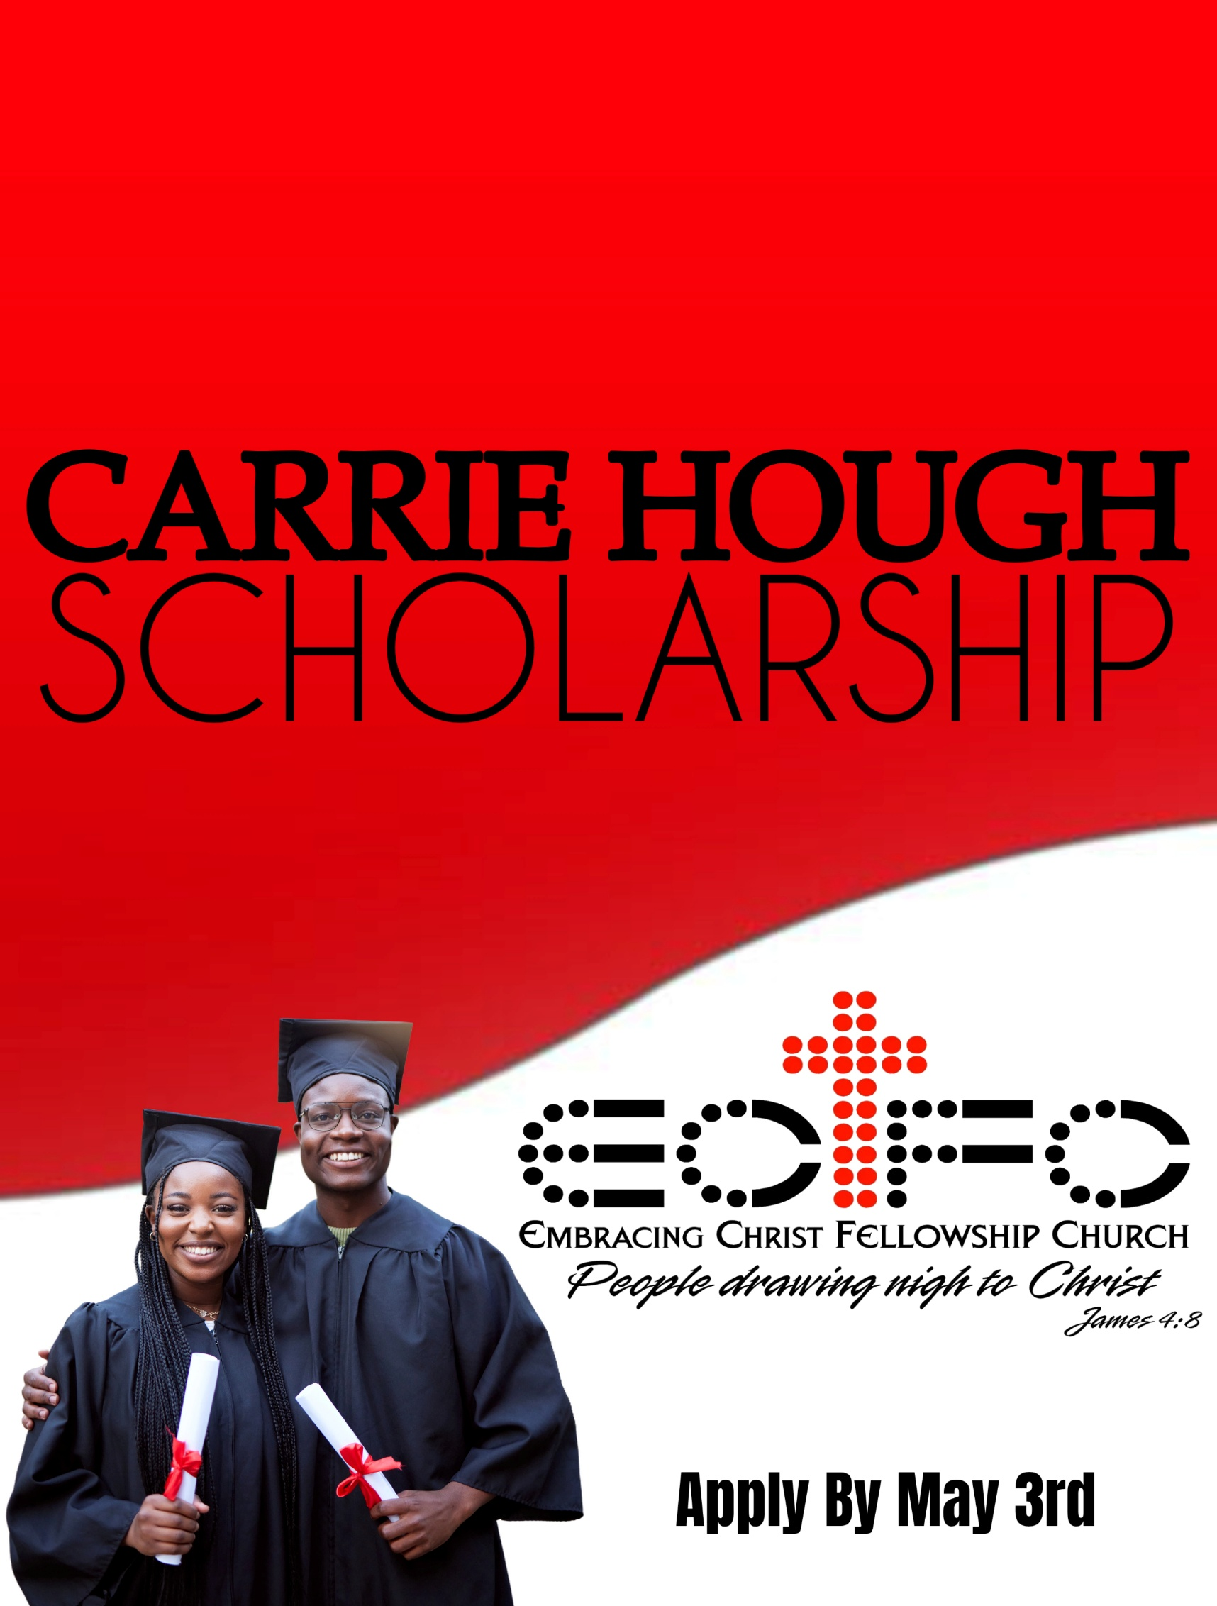

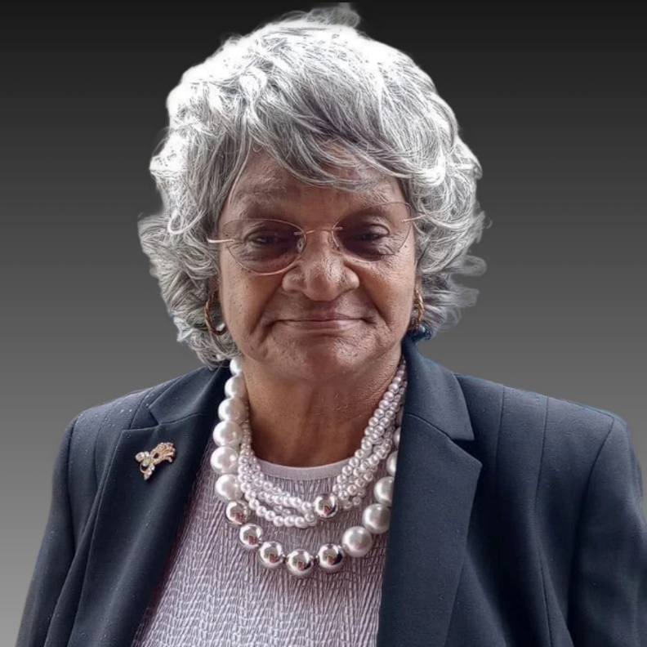
Deaconess Carrie Hough, born in 1941 in Jackson, South Carolina, was the eldest of three children. Her formative years under the nurturing care of her Big Mama, Betty Brooks, instilled in her strong values and a determined spirit. Her educational journey led her through Jefferson High School, where she graduated in 1962, marking the beginning of a remarkable life journey.
Carrie's bold decision to migrate to Long Island, New York, seeking broader opportunities, was a pivotal moment in her journey. There, she met her future husband, a meeting that would shape her future. Their union would later be blessed with two children, a son and a daughter.
1978 marked a significant turning point in Carrie's life. It was the year her husband preached his trial sermon, a moment that sparked the immediate embrace of her role in the church community. Her dedication to faith and community service was manifested in numerous ways, from providing transportation for fellow worshipers to leading the youth choir. Her spiritual commitment was further recognized when she was ordained as a Deaconess that same year.
In 1982, another chapter began when Carrie and her family relocated to Southport, North Carolina, following her husband's acceptance of a pastoral role at a local church. That same year, she began a long and distinguished career with Bald Head Island Limited, serving faithfully until 2015. Throughout her 33-year tenure, Carrie's exceptional work ethic and dedication earned her multiple Employee of the Month awards, highlighting her commitment to excellence in everything she undertook.
Carrie's life journey, from South Carolina to New York and finally to North Carolina, is a testament to the power of faith, family, and perseverance. Her adaptability and strength, as a mother, deaconess, and dedicated Employee, exemplified the values of hard work, spiritual devotion, and community service, as she has left an indelible mark on all the lives she touched.

About Carrie Hough Scholarship
The Carrie Hough Scholarship, a testament to the life and legacy of the emeritus Deaconess Carrie Hough, was established by the Embracing Christ Fellowship Church of Shallotte, NC. It was initiated by Bishop Michael L. Frink, deeply moved by her contributions, to support college-bound High School seniors. This $500.00 Scholarship stands as a profound tribute to her enduring impact on our community.
Deaconess Carrie, in her earlier years of ministry, was the wife of an AME Zion Pastor. Her role as the Pastor’s wife landed her the gracious task of working with the children in her congregation and her two children. If you asked her, she would disclose that some of her fondest time spent in ministry was nurturing and cultivating the lives of the children in her church. She taught them about Christ Jesus to ensure they could accomplish anything they pursued if they put God first. The scripture she lived, and still lives today, is Matthew 6:33 "But seek ye first the kingdom of God, and his righteousness; and all these things shall be added unto you." Even today, Deaconess Carrie has youth who have become adults who often remind her and thank her for the lasting impact she made in their lives.
Furthermore, this scholarship represents Deaconess Carrie's love and passion for the youth pursuing a better future. The recipient of this scholarship is not just obtaining a financial award; they are receiving a seed that awaits a flourishing harvest of success.
Who Can Apply?

To apply for the Carrie Hough Scholarship, you must meet the following requirements:
- Verify that you are a member or regular attendee of a Christian Church.
- Provide verification that you are in good standing to graduate with the 2026 High School graduating class.
- Attend school in Brunswick County, NC, or Horry County, SC.
- Currently have a 2.5 GPA or higher
- Plan to attend a College/University, Community College, or Trade School
- The deadline for submission for this scholarship is May 3rd, 2026.

For any questions, please get in touch with the Carrie Hough Scholarship committee at carriehoughscholarship@gmail.com.
SCHOLARSHIP APPLICATION PROCESS
CARRIE HOUGH SCHOLARSHIP APPLICATION
Personal Information
First Name: _________________________ Middle Name: __________Last Name: _____________________
Gender: Male Female
Mailing Address: ___________________________________________________________________________
City: ______________________________________State: __________________ Zip Code: ______________
Phone Number: (_____) _____________________________________________________________________
Email Address: _____________________________________________________________________________
Birth Date: ________________________________________________________________________________
High School
School Name: ______________________________________________________________________________
School Address: ____________________________________________________________________________
City: ______________________________________ State: _________________ Zip Code: _______________
Phone Number: (_____) ________________________ Fax Number: (____) ___________________________
Expected Graduation Date __________________________________GPA_____________________________
Local Church Information
Church Name: _____________________________________________________________________________
Church Address: ___________________________________________________________________________
City: ______________________________________State: _________________ Zip Code: _______________
Phone Number: (____) ______________________________________________________________________
Pastor Name: ______________________________________________________________________________
Name of College/Institute Attending in Fall: _____________________________________________________________________________
Intended Major/Field of Study: _____________________________________________________________________________
Other colleges/institutions that you've been accepted to: __________________________________________________________________________________________________________________________________________________________
(if necessary, continue separate sheets of paper and attach)

THE FOLLOWING DOCUMENTATION MUST BE RECEIVED FOR YOUR APPLICATION TO BE CONSIDERED COMPLETE:
- A completed application form.
- A letter of recommendation from your pastor or church official on church letterhead that describes your active involvement in your local church.
- It is crucial to include a copy of the acceptance letter from the college, university, vocational school, community college, or program you will attend. This document will help us understand your future plans and how the Carrie Hough Scholarship can support your academic journey.
- To be considered for the Carrie Hough Scholarship Committee, a one-page essay sharing how your faith in Christ Jesus affected your High School experience is a significant part of your application. This essay will provide us with a deeper understanding of your personal journey and how your faith has shaped your academic and personal life.

All applications and the above-noted documentation can be submitted online, by email, or by US Mail.

THE FOLLOWING DOCUMENTATION MUST BE RECEIVED FOR YOUR APPLICATION TO BE CONSIDERED COMPLETE:

- A completed application form.
- A letter of recommendation from your pastor or church official, on church letterhead, that describes your active involvement in your local church.
- A one-page essay sharing how your faith in Christ Jesus affected your High School experience.

BY MAIL:

If you’re mailing your application along with the required documentation, it must be postmarked by May 3rd and addressed to:
Carrie Hough Scholarship Committee
5051 Northside Drive
Shallotte, NC, 28470

BY EMAIL:
Submit a single PDF file to:
Carrie Hough Scholarship Committee
carriehoughscholarship@gmail.com
Tel: 910 620-0878

The email subject line must be read as follows:
CHSC 2026 Scholarship Application

Upon being awarded the Carrie Hough Scholarship, you must provide an official letter of acceptance from the college, university or vocational, community college or program that you will be attending. The scholarship check will be written specifically to that school.

